Dr. Bill Andrews
Biography
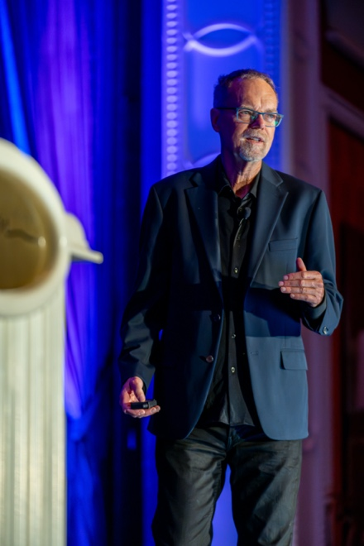
Dr. Bill Andrews is the Founder and CEO of Sierra Sciences, a company focused on finding ways to extend human lifespan and health span. Bill has been featured in Popular Science, The Today Show, The Doctor’s TV Show, and numerous documentaries on the topic of life extension. Bill co-stars with Dr. Aubrey de Grey in the documentary “The Immortalists” that made it to the “Top-10-List” to receive an Oscar in 2014 (see www.theimmortalists.com/watch). Bill will also be featured in the upcoming documentary called “Longevity Hackers” to be released in 2024.
Bill received his Ph.D. in Molecular & Population Genetics in 1981. Population Genetics is the study of the “Why” and “How” of Evolution as opposed to just the “What” and “When” that most evolutionary biologists focus on. Molecular Genetics, on the other hand, is the study of how to Control our own Evolution. Bill’s studies have focused on “Why” and “How” our species has evolved mechanisms to eliminate the longer-lived. These mechanisms include cancer, heart disease, and anything related to multiple Organ and Tissue Decline and Failure, etc. Aging is just an accumulation of all the different ways we have evolved to eliminate the longer-lived. Eliminating the longer-lived increases our species’ genetic diversity which increases our species’ ability to survive rapidly changing environments. And this explains why we have never evolved a way NOT to age, and never will unless we do it ourselves.
Speaking at the Cell Surgical Conference 2024
Bill believes that we are no longer at the mercy of evolution and his research focuses on how humans can control their own evolution. He has determined that the only real definite “hard-stop” to lifespan and health span, that is true for all humans, non-human primates, cats, dogs, horses, sheep, pig, and deer, is “Telomere Shortening”. No matter what else we do to treat aging, aging will never be cured and/or reversed unless we also solve the telomere shortening problem.
Before founding Sierra Sciences Bill was a medical researcher at Armos Corporation, Codon Corporation, Berlex Biosciences, Geron Corporation, and EOS Biotech. His research focused on cancer, heart disease, inflammation, and aging. Bill played key roles in the discoveries of Human Growth Hormone, Tissue Plasminogen Activator, Osteo-Inductive Factor, Erythropoietin, Beta-Seron, Telomerase, and Imetelstat, to name a few. In 1997 Bill was awarded 2nd Place as National Inventor of the Year for his cancer research. In the early-to-mid 1990s, while at Geron Corporation, Bill led the research to discover both the RNA and protein components of human telomerase, the enzyme responsible for preventing telomeres from shortening in our reproductive cells.
Presently, the primary focus of Sierra Sciences is to find ways to produce telomerase and lengthen telomeres in all cells of the human body, not just our reproductive cells, and eliminate this key hard-stop to super-longevity. But Bill is aware that the war against aging is not going to be won with just one battle.

